William Mackay
MTH 337, Professor Adam Cunningham

Weekly Report 06
Introduction
Kepler-453b, which was discovered recently, is a very interesting planet because of its unusual orbit. Unlike the planets in this solar system, which orbit a single star, Kepler-453b orbits a binary star system. This unique obit presents an interesting mathematical modeling challenge because the dynamics of the system differ greatly from those of a more typical solar system. A script was written in Python to attempt to model a simplified, two dimensional version of this binary star system using an improved version of Euler's method called Heun's method.
Approach
Some assumptions were made before modeling the system in order to simplify the process. First, the system was assumed to be two dimensional, which meant that the entire system could be represented in the x-y plane. Second, each sun was assumed to have equal mass and be an equal distance from the origin. The motion of the suns was also assumed to be a “solved problem”. The two suns rotated circularly about one another, and each sun's position at a time t could be found using the equations below.
(1)
(2)
In order to model the motion of the planet, the forces on the planet needed to be calculated. The planet would have a gravitational attraction to both suns based on its distance from each. The acceleration of the planet in the x and y directions due to gravity was calculated using the universal law of gravitation, or. From this equation, the acceleration of the planet due to gravitational forces from both suns can be found from the equations below.
(3)
(4)
The state of the planet at each time step was represented as a four element vector, P, which contained the planet's x position, y position, x velocity, and y velocity. The derivative of this vector, dP/dt, was a vector containing x velocity, y velocity, x acceleration, and y acceleration. This derivative vector changed each time step due to the change in the positions of the suns at each time step. The derivative of the state vector was necessary in performing Heun's method for each time step. Heun's method is based on Euler's method, which approximates a the state of a system which is one time step (h) in the future using the previous state and the rate of change of the state (). Heun's method improves on Euler's method by averaging the predicted state from the current time step with the state predicted using the first prediction. The two equations used during each time step are shown below.
(5)
(6)
In order to implement this in Python, the process of numerically estimating the state of the planet at each time step was broken up into functions. The first was sun_position(R,t), which, when given a time and radius, would return the x and y location of each sun using equations 1 and 2. diff_P_binary(P,t) returned the derivative of the planet's state vector P at a time t. The first two elements were simply the planet's x and y velocities from that time step. The second two elements were the x and y accelerations of the planet, which were calculated using equations 3 and 4. These equations are dependent on the locations of the suns at the current time step, and so sun_position(R,t) is called in the function. The next function, heun_orbit_binary(steps, h, x=3, y=0, v_x=0, v_y=0.5), used diff_P_binary and equations 5 and 6 to perform Heun's method for a given number of steps and a time step h and return a full orbital trajectory. The default x, y, v_{x}, and v_{y} are also defined in the function. The last function used to generate orbital trajectories was plot_orbit(orbit), which simply plotted the x and y values of the given orbit. In order to generate many trajectories with many different initial conditions, the heun_orbit_binary(steps,h) and plot_orbit(orbit) functions were called in a pair of nested for-loops. These pairs of for-loops plotted each orbit in a subplot in order to visualize many trajectories on the same figure.
The animation functions from the matplotlib library were used to visualize a single orbit over the course of some time so that the behavior of the planet could be observed as well as its trajectory. To do this, first the points for the suns and the planet were initialized as well as the lines for their trajectories. Then init() and animation(i) functions were defined for the matplotlib animation function FuncAnimation. The full trajectory is plotted on the same figure, as well. In the provided code, a stable orbit is shown in the animation.
Results
The trajectories resulting from the tests performed in the Python script are shown in figures 1 and 2. In each figure, 49 initial x position and y velocity combinations were plotted. The trajectories shown in the first plot had initial x positions varying from 0.6 to 1.8 and initial y velocities varying from 0.7 to 1.3.The trajectories shown in the second plot had initial x positions varying from 2.0 to 3.2 and initial y velocities varying from 0.3 to 0.9. These orbits were simulated using a time step of 0.1s over 1000 steps.
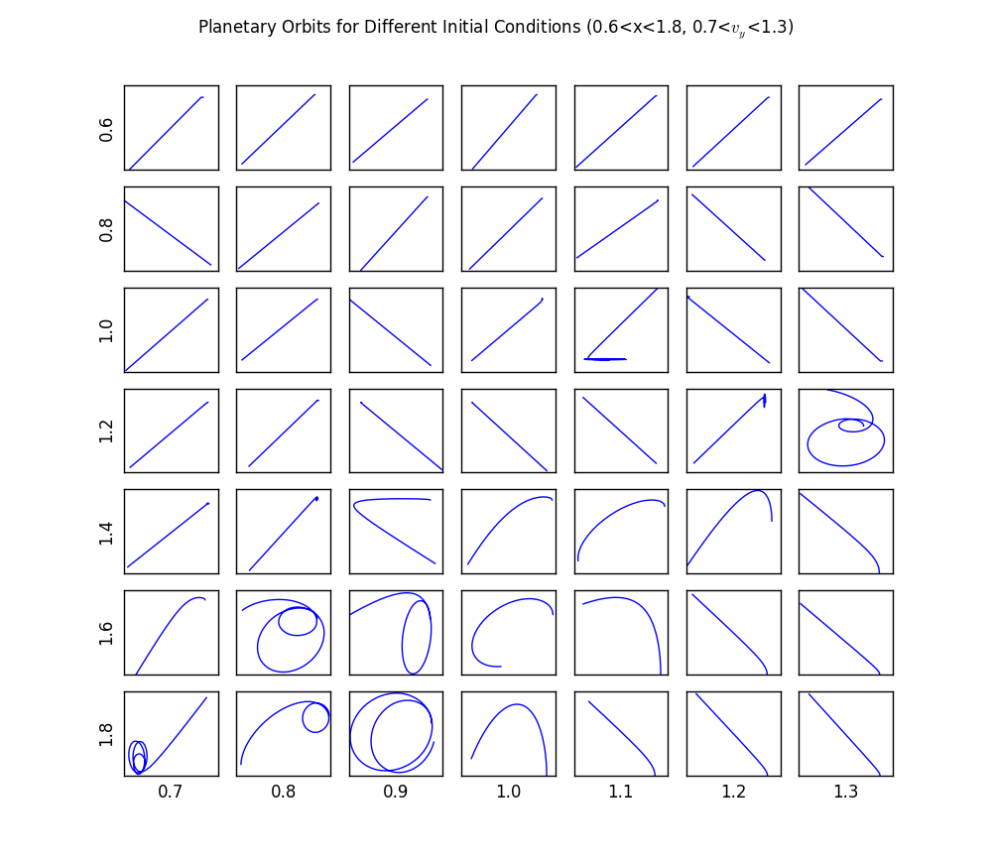Figure 1

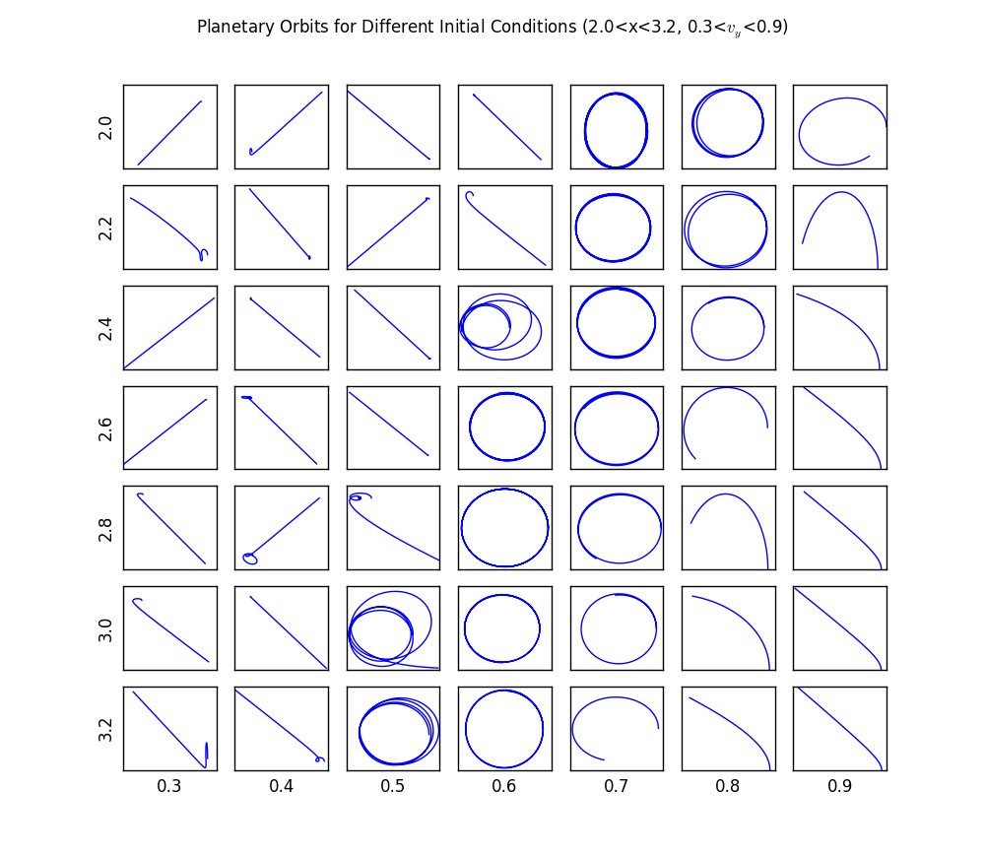Figure 2
The animated orbit cannot be displayed in this report, but can be generated using the provided Python code.

Conclusion
Of the nearly 100 trajectories plotted in figures 1 and 2, not many of them are stable. Many of the trajectories exhibit a lot of strange behavior as a result of the binary star system. Most of the time, the planet ends up being flung out of its orbit. The smallest stable orbital radius, from the figures, appears to be 2.0. Two orbits are shown to be stable at this radius, one with an initial y velocity of 0.7 and another with a velocity of 0.8. Because these orbits were only simulated over the course of 1000 time steps, it is possible that these orbits would become unstable if simulated for a longer period of time. It can be seen from the figures that as initial orbital radius increases, the velocity required for a stable orbit decreases. When the initial radius is 2.0, the required velocity is 0.7, but this velocity decreases to 0.6 when the radius increases to 3.2. The accuracy of this simulation could have been improved by decreasing the size of the time step. With a smaller time step, some of the unstable or almost stable orbits might show much better behavior, possibly revealing a closer stable orbit.
Python Code

#William Mackay
#MTH 337 Report 06 Python Script- Planet orbiting a binary star system

from pylab import *
from matplotlib import animation

#Defining Functions to simulate orbits
def sun_position(R,t):
x1=R*cos(t)
x2=-x1
y1=R*sin(t)
y2=-y1
return x1,x2,y1,y2

def diff_P_binary(P,t):
G=1.0
M=0.5
R=0.5
x,y,v_x,v_y=P
x1,x2,y1,y2=sun_position(R,t)
r31=(sqrt((x-x1)**2+(y-y1)**2))**3
r32=(sqrt((x-x2)**2+(y-y2)**2))**3
a_x=(-G*M*(x-x1))/r31+(-G*M*(x-x2))/r32
a_y=(-G*M*(y-y1))/r31+(-G*M*(y-y2))/r32
return array([v_x,v_y,a_x,a_y])

def heun_orbit_binary(steps,h,x=3,y=0.,v_x=0., v_y=0.5): #x,y,v_x,v_y are default initial conditions
R=0.5
orbit=empty((steps,4))
P=array([x,y,v_x,v_y])
for i in xrange(steps):
orbit[i]=P
P_tilde=P+h*diff_P_binary(P,h*i)
P+=(h/2)*(diff_P_binary(P,h*i)+diff_P_binary(P_tilde,h*i))
return orbit

def plot_orbit(orbit):
plot(orbit[:, 0], orbit[:, 1])

#Simulating Orbits
steps=5000
h=0.1
R=0.5

orbit_anim = heun_orbit_binary(steps, h,x=2,y=0.,v_x=0., v_y=0.7)
sun_orbit=empty((steps,4))
for i in xrange(steps):
sun_orbit[i]=sun_position(R,h*i)

#Plotting and animating
fig, ax = subplots(figsize=(6, 6))
ax.set_aspect('equal')
ax.set_axis_bgcolor('k')
point, = plot([], [], 'ro',ms=6)
line, = plot([], [], 'cyan')
sun1_point, = plot([],[], 'yo', ms=12)
sun1_line, = plot([], [], 'cyan')
sun2_point, = plot([],[], 'yo', ms=12)
sun2_line, = plot([], [], 'cyan')
sizex = 5#1+abs(max(orbit_anim[:,0]))
sizey = 5#1+abs(max(orbit_anim[:,1]))
xlim(-sizex, sizex)
ylim(-sizey, sizey)

def init():
point.set_data([], [])
line.set_data([], [])
sun1_point.set_data([], [])
sun1_line.set_data([], [])
sun2_point.set_data([], [])
sun2_line.set_data([], [])
return line, point, sun1_point, sun1_line, sun2_point, sun2_line,

def animate(i):
point.set_data(orbit_anim[i, 0], orbit_anim[i, 1])
line.set_data(orbit_anim[:i, 0], orbit_anim[:i, 1])
sun1_point.set_data(sun_orbit[i,0],sun_orbit[i,2])
sun1_line.set_data(sun_orbit[:i,0],sun_orbit[:i,2])
sun2_point.set_data(sun_orbit[i,1],sun_orbit[i,3])
sun2_line.set_data(sun_orbit[:i,1],sun_orbit[:i,3])
return line, point, sun1_point, sun1_line, sun2_point, sun2_line,

ani=animation.FuncAnimation(fig, animate, init_func=init, frames=steps, interval=20, blit=True, repeat=True)
plot_orbit(orbit_anim)

#Now simulating many orbits for an array of initial x values and y velocities
end=7
initial_x1=linspace(0.6,1.8,end)
initial_v_y1=linspace(0.7,1.3,end)
initial_x2=linspace(2.0,3.2,end)
initial_v_y2=linspace(0.3,0.9,end)
steps=1000
h=0.1
i=1
figure(figsize=(10, 10))
xlim(-4,4)
ylim(-4,4)
for row in range(1, end + 1):
for col in range(1, end + 1):
orbit=heun_orbit_binary(steps,h,x=initial_x1[row-1],y=0.,v_x=0., v_y=initial_v_y1[col-1])
subplot(end, end, i)
plot_orbit(orbit)
xticks([])
yticks([])
if i % end == 1:
ylabel(str(initial_x1[row-1]))
if i > end**2-end:
xlabel(str(initial_v_y1[col-1]))
i += 1
suptitle('Planetary Orbits for Different Initial Conditions (0.6<x<1.8, 0.7<$v_y$<1.3)')

i=1
figure(figsize=(10, 10))
xlim(-4,4)
ylim(-4,4)
for row in range(1, end + 1):
for col in range(1, end + 1):
orbit=heun_orbit_binary(steps,h,x=initial_x2[row-1],y=0.,v_x=0., v_y=initial_v_y2[col-1])
subplot(end, end, i)
plot_orbit(orbit)
xticks([])
yticks([])
if i % end == 1:
ylabel(str(initial_x2[row-1]))
if i > end**2-end:
xlabel(str(initial_v_y2[col-1]))
i += 1
suptitle('Planetary Orbits for Different Initial Conditions (2.0<x<3.2, 0.3<$v_y$<0.9)')
show()

